 | Cabin Crew Training and Flight Crew Training |  |  | 
 |  | Other Courses
 |  |  | Water Survival Training

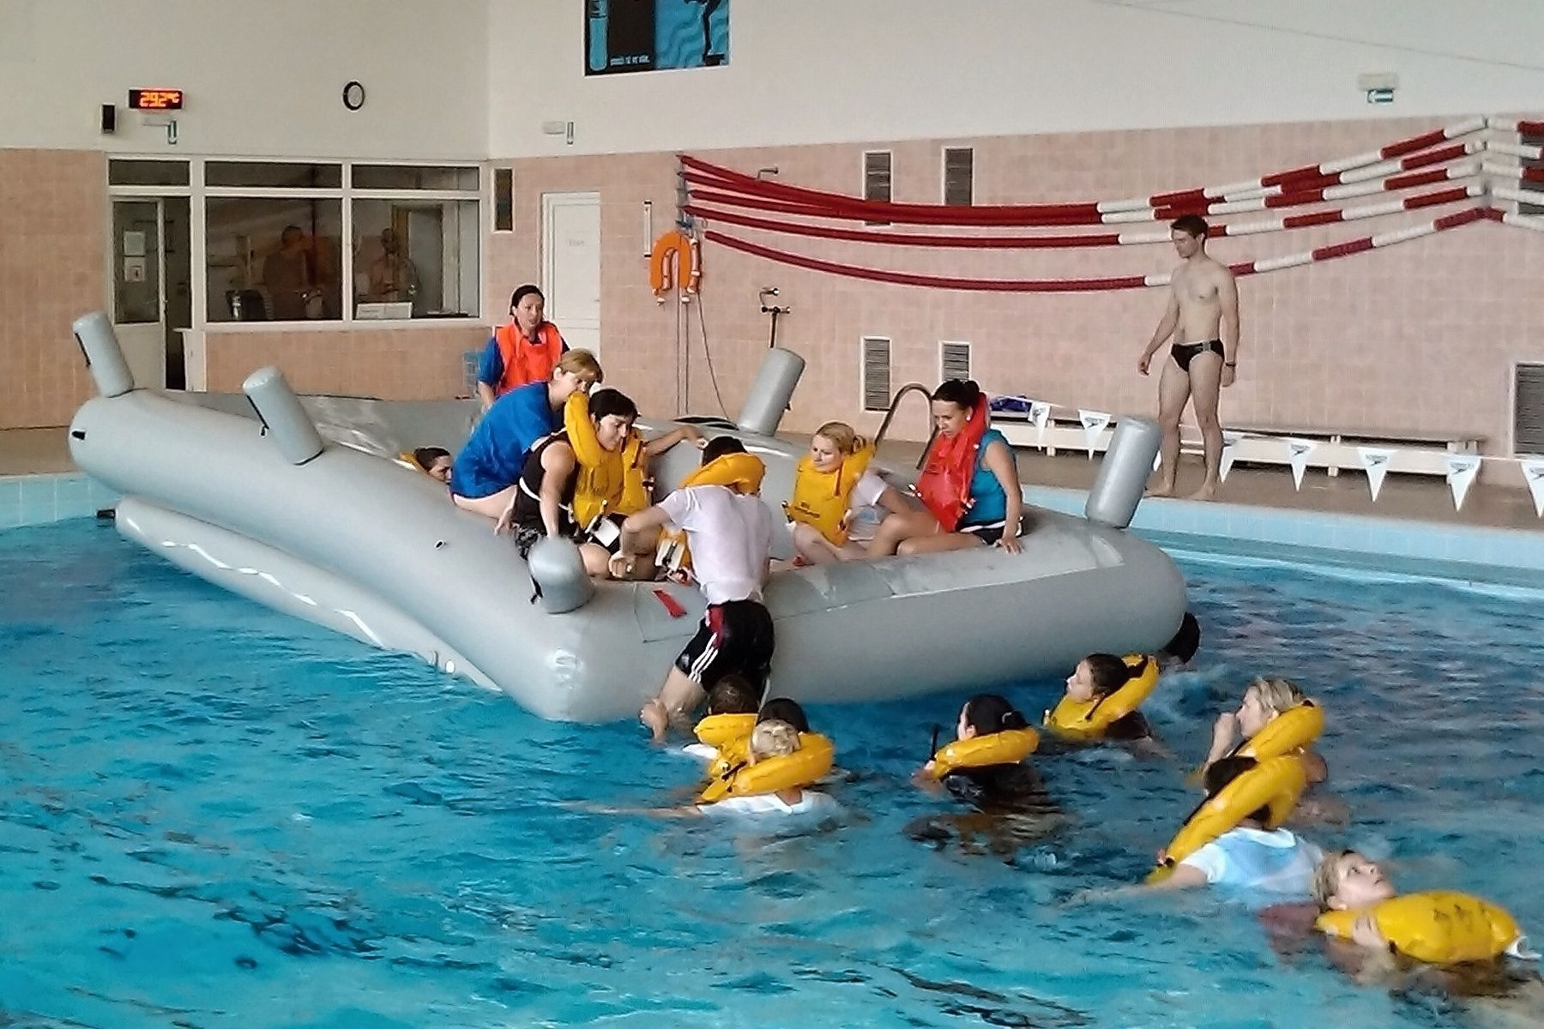

Initial Situation
A student needs to undergo a Water Survival Training.

Course Objective
During the Water Survival Training, students should acquire knowledge of the aeroplane´s water survival equipment, skills to control and use all water survival equipment and awareness of all CC and FC assignments and procedures in the emergency situations.

Entry Requirements
- Ability to swim at least 50 metres in 2 minutes

Course Description and Duration
The Water Survival Training is held by our Survival Training Instructor. Topics covered during the theoretical part this training are as follows: life vests (practical use), description and construction of slide-rafts, use of a slide-raft including relevant equipment, signalling and safety equipment of in case of ditching.
Practical part follows the theoretical one to acquire required skills in operation of water survival equipment and practical procedures.
This training is tailored for both flight and cabin crew qualifications.

Theoretical Training | Location/Device/Tools
- Classroom Instruction  - min. 1 hr. of classroom instruction with a Survival Training Instructor | Classroom

Practical Training & Testing | Location/Device/Tools
- Swimming pool  - 2 hours of practical training  - Life vests usage, life raft inflation, usage, minor raft repairs etc. | Swimming Pool

The training can be adjusted according to customer´s requirements.

Optional Training or Optional Modules of This Course
The basic form of this training can be adjusted by selection of additional or optional trainings according to specific needs of the customer:
Additional training | Location/Device/Tools
- Fire and Smoke Training  - Fire prevention and practical fire-fighting in cabin fire-fighting trainer  - Can be adjusted to the customer´s needs | Classroom/  Fire Fighting Trainer
- Evacuation Slide and Emergency Training  - Aircraft evacuation training using slides and other emergency situations  - Can be adjusted to the customer´s needs | Classroom/  CEET (Cabin Emergency Evacuation Trainer)

Course Completion Certificate
This is a course for operators in accordance with regulation (EU) 965/2012. CATC provides this course under the approval of the customer and its completion may be certified in operator’s training documents or with our certificate of completion referring to customer’s OM-D.
For more information, please contact info@catc.cz.

