 | Cabin Crew and Flight Crew Training |  |  | 
 |  | Other Courses
 |  |  | Fire and Smoke Training

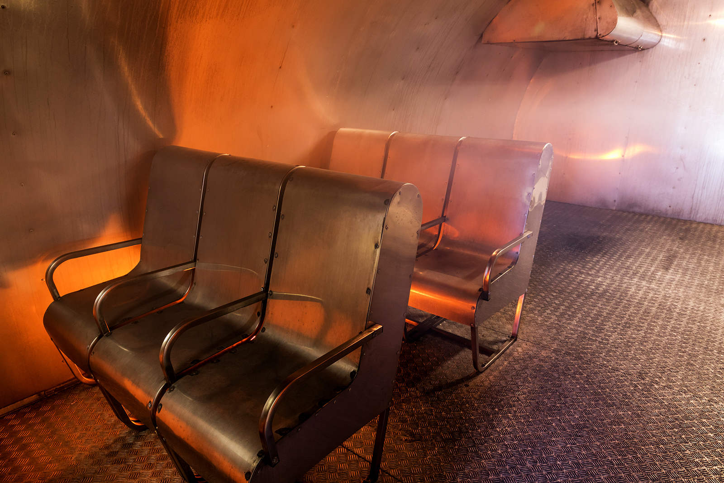
Initial Situation
A student needs to undergo a Fire and Smoke Training.

Course Objective
During the Fire and Smoke Training, students should acquire knowledge of the aeroplane´s fire and smoke equipment, skills to control and use all fire and smoke equipment and awareness of all CC and FC assignments and procedures in the situations trained.

Entry Requirements
None.

Course Description and Duration
The Fire and Smoke Training is held by our Fire and Smoke Training Instructor. Topics covered during the theoretical part this training are fire prevention and smoke in passenger cabin and type specific equipment and procedures.
During the practical training, practical extinguishing takes place, including donning of portable full-face masks by each attendant in an enclosed simulated smoke-filled environment.
This training is tailored to both flight and cabin crew qualifications.

Theoretical Training | Location/Device/Tools
- Classroom Instruction | Classroom

Practical Training & Testing | Location/Device/Tools
- Fire Trainer | Fire Fighting Trainer

The training and its duration can be adjusted according to customer´s requirements.

Optional Training or Optional Modules of This Course
The basic form of this training can be adjusted by selection of additional or optional training according to specific needs of the customer:
Additional training | Location/Device/Tools
- Water Survival Training  - Water survival and practical training, including life vests and rafts usage  - Can be adjusted to the customer´s needs | Classroom/  Swimming Pool
- Evacuation Slide and Emergency Training  - Aircraft evacuation training using slides and other emergency situations  - Can be adjusted to the customer´s needs | Classroom/  CEET (Cabin Emergency Evacuation Trainer)

Course Completion Certificate
This is a course for operators in accordance with regulation (EU) 965/2012. CATC provides this course under the approval of the customer and its completion may be certified in operator’s training documents or with our certificate of completion referring to customer’s OM-D.
For more information, please contact info@catc.cz.

